Final Word Cloud

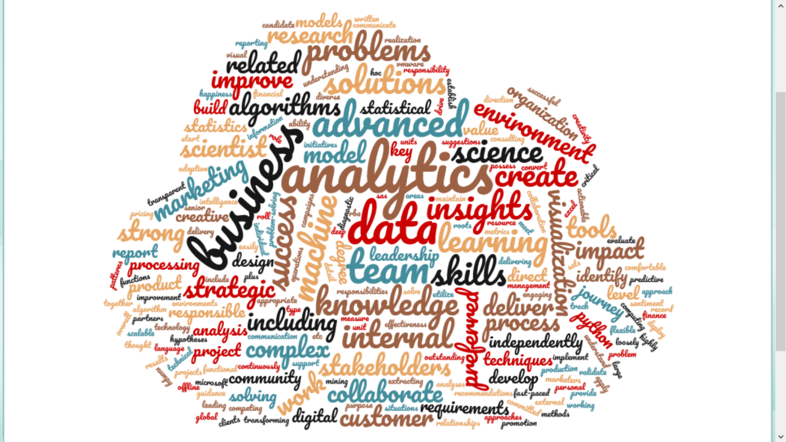

* Top Roles
  + AVP data analytics
  + Business Intelligence Developer
  + Data Scientist

**AVP data analytics**- This role is responsible for managing a small team, developing routines supporting the auditors, creating / maintaining various monitoring dashboards and identifying opportunities to enhance and optimize the existing program. The right individual will leverage their past experiences working with large data sets to 1) provide risk and control insights, 2) create automated and reusable analytics tools to identify anomalies and exceptions, and 3) create tools to continuously monitor and trend key activities of the business (e.g., KRIs/KPIs). This is a highly collaborative role, working directly with the audit teams as well as the department’s senior management.

*Key words from word cloud: Collaborative, team, data analytics, insights*

**Business Intelligence Developer**: The Business Intelligence Developer is responsible for rapidly developing complex data visualizations, insights and analytics for senior business leaders to help drive a high performing firm and contribute to the company’s strategic initiatives and goals.

* Design and develop complex business intelligence analyses utilizing complex data from numerous sources.
* Collaborate with data management team to ensure smooth flow of data from centralized sources.
* Work with data management and other teams to gather and maintain non-centralized data sources.
* Develop and deploy BI analyses. Deliver agile insights solutions developed collaboratively with colleagues and internal clients, often with a short turnaround time.

*Key words: business Intelligence analyses, complex data, collaborative, insights, analytics*

**Data Scientist**: We are looking for a highly qualified Data Scientist for our Predictive Analytics for Prescriptive Maintenance team who has a strong background data mining, statistical prediction, and machine learning. Someone with modern data analytics tools including, but not limited to, Python, R, and related packages such as TensorFlow and Scikit in popular cloud environments such as AWS.

*Key words: data science, statistical prediction, machine learning, validation*